

THE SENTINARI ADVERSARIAL R&D CHALLENGE

A Framework for 4-Hour Empirical Auditing, Root-Cause Elucidation, and Cross-Functional Validation

Author Note
No institutional funding or grants supported the research or the creation of the full-stack application.

Table of Contents
List of Figures 2
List of Tables 2
SECTION 1: THE SILO BLIND SPOT (THE POSITIONING PIVOT) 3
1.1 The Myth of the In-House Solution 3
1.2 Changing the Proposition: The Adversarial Audit 4
SECTION 2: THE 4-HOUR CHALLENGE BLUEPRINT 5
2.1 The Accelerated Processing Workflow 5
SECTION 3: CORE COMPONENT MATRIX OF THE RESPONSE PAPER 6
SECTION 4: ENTERPRISE OUTCOMES: THE SYMBIOSTIC HOOK 8
Options Forward 9

List of Figures

Figure 1: Example of the Pseudo Dynamic Lab as is improves and enhances it’s own code to be challenged by any entity 37
Figure 2: International Guidelines and ISO Standard 52

List of Tables
No table of figures entries found.

THE SENTINARI ADVERSARIAL R&D CHALLENGE
A Framework for 4-Hour Empirical Auditing, Root-Cause Elucidation, and Cross-Functional Validation

SECTION 1: THE SILO BLIND SPOT (THE POSITIONING PIVOT)

1.1 The Myth of the In-House Solution

Modern enterprise industries—whether Pharmaceuticals, Aerospace, FinTech, or Energy—rely on highly specialized, single-domain simulation suites and legacy research frameworks. These platforms possess a critical, systemic vulnerability: they optimize exclusively within their own parameters.

Because corporate R&D processes operate within commercial silos, they are fundamentally blind to cross-functional disruptions, systemic algorithmic distortions, and hidden structural dependencies that originate outside their defined fields. When an enterprise encounters an intractable R&D bottleneck or a critical operational failure, their specialized software routinely attempts to fix the symptom rather than diagnosing the cross-disciplinary root cause.

1.2 Changing the Proposition: The Adversarial Audit

Sentinari does not compete with existing enterprise software; it audits them.
By remaining intentionally decoupled from any single industry, Sentinari functions as a cross-functional pattern recognition engine. It ingests an enterprise's current problem space, projects it onto a global, multi-disciplinary vector field, and screens it against 21 Sentinel Scientific Disciplines. The core objective is to identify exactly where the enterprise’s localized assumptions violate foundational first principles, structural dependencies, or global regulatory boundaries.

Figure 1: Enterprise Silhouette Blindspot
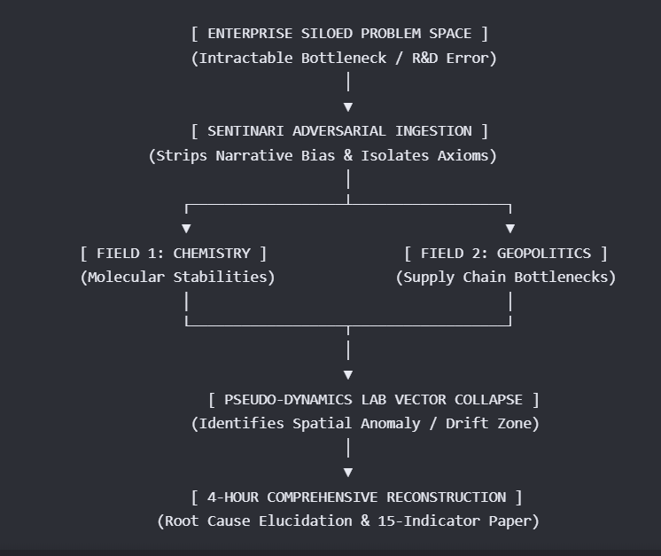

SECTION 2: THE 4-HOUR CHALLENGE BLUEPRINT

The proposition to industry headers is direct, low-friction, and high-impact: Submit an active, unsolved R&D blocker or systemic problem under a Free-of-Charge (FOC) protocol. Within 4 hours, Sentinari generates a comprehensive, 15-to-18-page publication-grade R&D Validation Paper mapping the exact source of error, the root cause, and an actionable, evidence-traceable pathway to resolution.

2.1 The Accelerated Processing Workflow

Hour 01 (Ingestion & Filtering): The problem is parsed through the Gateway Guardian. It strips away corporate terminology and commercial narrative bias, reducing the challenge to its core mathematical, physical, or behavioral first principles.

Hour 02 (Vector Mapping & Superposition): The isolated parameters are projected into the central vector database. Sentinari scans across its curated, citation-graded repositories to analyze where this specific problem configuration overlaps with hidden variables in adjacent scientific fields.

Hour 03 (Adversarial Simulation): The trajectory is run through the Pseudo-Dynamics Lab. The simulation checks the enterprise’s current approach for algorithmic distortion and semantic drift. It measures where the enterprise's current models break down, pinpointing the specific variable or constraint causing the system failure.

Hour 04 (Synthesis & Output Generation): Sentinari constructs the formal R&D paper. The architecture dynamically compiles the findings, inserts relevant mathematical proofs, embeds strict APA 7th source citations, and writes actionable, risk-aware recommendations.

SECTION 3: CORE COMPONENT MATRIX OF THE RESPONSE PAPER

The generated 15-to-18-page validation document is structured to provide immediate, undeniable proof of its findings by utilizing a standardized 15-Indicator Matrix:
Indicator Section | Technical Content | Enterprise Value
1. The Axiomatic Isolation | Deconstructs the submitted problem into its foundational, domain-agnostic first principles. | Strips out corporate assumptions and confirms absolute clarity on the problem space.
2. Root Cause Elucidation | Pinpoints the exact coordinate of error (e.g., a hidden material fatigue limit, a miscalculated algorithmic weight, or an unmapped regulatory dependency). | Halts the speculative, costly trial-and-error cycle within the corporate R&D team.
3. Vector Drift Analysis | Displays the trajectory mapping from the Pseudo-Dynamics Lab, showing exactly where the enterprise's current models experience cognitive drift or hallucination. | Visually demonstrates the structural blind spots of their current software infrastructure.
4. Cross-Functional Trajectory | Maps out how variables from multiple distinct fields interact to perpetuate the bottleneck. | Reveals hidden, multi-disciplinary correlations that single-field specialists miss.
5. Mathematical Formulations | Implements exact KaTeX mathematical proofs verifying the causal discontinuities in the problem space. | Elevates the findings to undeniable, peer-reviewed scientific certainty.
6. Net Sustainable Impact Score | Scores the suggested solutions against the 7-Dimensional Matrix to calculate long-term social and economic viability. | Guarantees compliance with international sustainability metrics and risk frameworks.
7. Actionable Pathways | Outlines at least three distinct, highly constrained operational routes to bypass or resolve the error. | Provides the engineering and executive teams with an immediate, validated blueprint for action.
8. Cryptographic Provenance | Attaches explicit APA 7th works cited, tracking every assertion to a cryptographically timestamped source address. | Builds absolute, auditable trust in discovery without reliance on generalized AI oracles.

SECTION 4: ENTERPRISE OUTCOMES: THE SYMBIOSTIC HOOK

By executing this challenge, you transform your sales process from an abstract software pitch into a visceral demonstration of capability. You show them their own mistakes before asking for a single cent.

Figure 2: Value added – without any momentary investment or time cuts any project
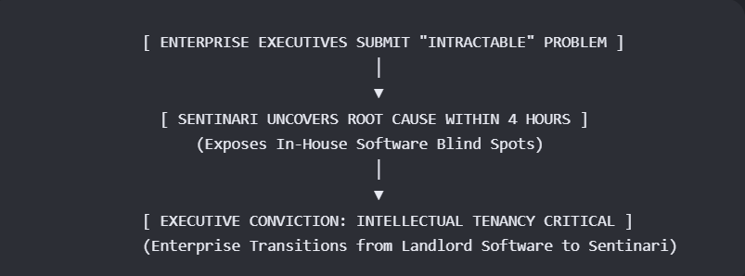

Options Forward

Option A: Should Sentinari fails to meet the deliverables, you have zero monetary, zero time lost on production on any costly time-driven project. You will have indication to the extend that your R&D Platform International Guidelines (or we can leave this section out).

Option B: If we do succeed in achieving the deliverables, kindly grant us and Audience to discuss the possibilities’ and value-adding proposition of Sentinari to your organisation?

